

|  |
| --- |
| **FPT UNIVERSITY** |
| Capstone Project Document |

**SMARTMEDICINEDICTIONARY**

Report#2 - Software Project Management Plan

|  |  |  |  |  |  |  |  |  |  |  |  |  |  |  |  |  |  |  |  |  |
| --- | --- | --- | --- | --- | --- | --- | --- | --- | --- | --- | --- | --- | --- | --- | --- | --- | --- | --- | --- | --- |
| |  |  | | --- | --- | | **Smart Medicine Dictionary** | | | **Group Members** | |  |  | | --- | --- | | Lê Thị Xuân | 01913 | | Phạm Huy Khôi | 01888 | | Phạm Minh Tú | 01770 | | PhạmHàHải | 01727 | | Ngô Hà Thu | 01522 | |  |  | | | **Supervisor** | Mr. Nguyễn Văn Sang | | **Project code** | SMD | |
| - Hanoi, 8/2013-  Table of Contents  1 Project Overview 3  1.1 Project Description 3  1.2 Scope 4  1.3 Milestone and Deliverables 5  1.4 Standard Objectives 6  2 Project organization 7  2.1 Software Process Model 7  2.1.1 Rational Unified Process Model 7  2.1.2 Why RUP? 10  2.1.3 Project Life Cycle 11  2.2 Roles and Responsibilities 12  2.3 Tools and Infrastructures 15  2.3.1 Development environment 15  2.3.2 Deployment environment 15  3 Project Schedule 17  3.1 Task Sheet: Assignments and Timetable 17  3.2 Meeting Schedule 19  4 Effort Estimation 20  5 Risk Management 21 |
|  |

# **Project Overview**

## Project Description

Nowadays, there are few system are using information technology in the medical field and each system still has many disadvantage and limitation. Building this system, our target is to create an entirely new system, improve the limitation of current system and propose some new features that make our system is different with the others. The system has two versions: for mobile and for web. The mobile application will be based and run on smart phone support Android OS. With the integration of Google Map API, the application will be guaranteed with a high rate of reliability in the search and display location and path to nearest pharmacy location. There are some points that make smart medicine dictionary be different from other products:

- Support Vietnamese language.

- Using map to display location and path to the nearest pharmacy location.

- Friendly interface, easy to understand terms.

- No need account for normal users to use product.

- Having interaction between medicine and pharmacy.

- Advanced search with many criteria and accuracy information.

## Scope

Due to the time constraint of a capstone project, scope of our system includes:

- Develop user requirement and software requirement specification

- Develop architecture and detailed design documents

- Coding and unit test

- Develop test case and execute system test

- The developing software will have the following functions

|  |  |  |  |
| --- | --- | --- | --- |
| **No** | **Group of functions** | **Function** | **Description** |
| **1** | **Search Module** | Search Medicine By Name |  |
| Advanced Search Medicine |  |
| Search Pharmacy By Name |  |
| Advanced Search Pharmacy |  |
| Find Nearest Pharmacy Location |  |
| **2** | **Pharmacy Module** | Register new pharmacy information |  |
| Change pharmacy information |  |
| Add new sold medicine |  |
| **3** | **Administration Module** | Search Medicine |  |
| Add new medicine |  |
| Update medicine |  |
| Delete medicine |  |
| Restore medicine |  |
| Copy new medicine |  |
| Search pharmacy |  |
| Accept registered pharmacy |  |
| Reject registered pharmacy |  |
| Delete pharmacy |  |
| Login |  |
| Logout |  |
| Reset password |  |
| Change password |  |
| Count the number of visitors |  |
| Count the number search of a pharmacy |  |
| Medicine censorship |  |
| **4** | **Diary Module** | Medication Diary |  |
| **5** | **News module** | Read News |  |
| Restore News |  |
| Add News |  |
| Edit News |  |
| Delete News |  |
| Copy new News |  |

**Table 2-1:** Functions Group

In the future when having time and other condition we will develop and add function diagnose the diseases online. User can enter symptoms and answer some questions, system will diagnose and give treatments with high accuracy

## Milestone and Deliverables

|  |  |  |  |  |  |  |
| --- | --- | --- | --- | --- | --- | --- |
| **No** | **Stage** | **Deliverable/ Milestone** | **Delivery Date** | **Inspect** | **Final** | **Delivery Location** |
| 1 | Inception | Business Case | 10-May-2013 |  |  | Project team |
| 2 | Inception | Feasibility study | 12-May-2013 |  |  | Project team |
| 3 | Inception | Complete draft screen prototypes | 24-May-2013 |  |  | Supervisor |
| 4 | Inception | Complete draft ERD diagram | 23-May-2013 |  |  | Supervisor |
| 5 | Inception | Complete draft requirements | 27-May-2013 |  |  | Supervisor |
| 6 | Inception | Deliver Report No.1 | 28-May-2013 |  |  | Supervisor |
| 7 | Inception | Project plan | 31-May-2013 |  |  | Supervisor |
| 8 | Inception | Deliver Report No.2 | 6-June-2013 |  |  | Supervisor |
| 9 | Elaboration | User Requirement Specification | 7-June-2013 |  |  | Supervisor |
| 10 | Elaboration | Complete ERD | 10-June-2013 |  |  | Supervisor |
| 11 | Elaboration | Final Prototype | 12-June-2013 |  |  | Supervisor |
| 12 | Elaboration | Database Model | 14-June-2013 |  |  | Supervisor |
| 13 | Elaboration | Software Requirement Specification | 24-June-2013 |  |  | Supervisor |
| 14 | Elaboration | Deliver Report No.3 | 25-June-2013 |  |  | Supervisor |
| 15 | Elaboration | Deliver Report No.4 | 17-July-2013 |  |  | Supervisor |
| 16 | Construction | Coding training Report | 2-July-2013 |  |  | Supervisor |
| 17 | Elaboration | System Architectural Design | 16-July-2013 |  |  | Supervisor |
| 18 | Construction | Complete Coding | 24-July-2013 |  |  | Supervisor |
| 19 | Construction | Component/Code | 26-July-2013 |  |  | Supervisor |
| 20 | Construction | System Test Package | 26-July-2013 |  |  | Supervisor |
| 21 | Construction | Deliver Report No.5 | 5-August-2013 |  |  | Supervisor |
| 22 | Construction | Deliver Report No.6 | 9-August-2013 |  |  | Supervisor |
| 23 | Transition | Project Review-Lessons Learned | 9-August-2013 |  |  | Supervisor |
| 24 | Transition | The last Document and CD source code | 19-August-2013 |  |  | FU |
| 25 | Transition | Project completed | 27-August-2013 |  |  | FU |

**Table 2-2**: Project Milestone and Deliverables

## Standard Objectives

|  |  |  |  |  |
| --- | --- | --- | --- | --- |
| Metrics | Unit | Committed | Actual | Deviation |
| Start Date | dd-mmm-yy | 13-May-13 | 13-May-13 | 0 days |
| End Date | dd-mmm-yy | 10-Aug-13 | 10-Aug-13 | 0 days |
| Duration | elapsed days | 89 days | 89 days | 0 days |
| Maximum Team Size | Person | 5 | 5 | 0 |

**Table 2-3**: Project Standard Objectives

# **Project organization**

## Software Process Model

The selection of an appropriate development process model with project development schedule is very important. So, our team decided to choose Rational Unified Process model to develop our project.

### **Rational Unified Process Model**

The Rational Unified Process is a Software Engineering Process. It provides a disciplines approach to assigning tasks and responsibilities within a development organization. Its goal to ensure the production of high-quality software that meets the needs of its end-users, within a predictable schedule and budget.

The Rational Unified Process (RUP) is an interative software development process framework created by the Rational Software Corporation, a division of IBM since 2003. RUP is not a single concrete prescriptive process, but rather an adaptable process framework, intended to be tailored by the development organizations and software project teams that will select the elements of the process that are appropriate for their needs. RUP is a specific implementation of the Unified Process. (<http://en.wikipedia.org/wiki/IBM_Rational_Unified_Process>).

The process diagram can be described in two demensions, or along two axis:

The horizontal axis represents time and shows the dynamic aspect of the process as it is enacted, and it is expressed in terms of cycles, phases, iterations, and milestones.

The vertical axis represents the static aspect of the process: how it is described in terms of activities, artifacts, workers and workflows

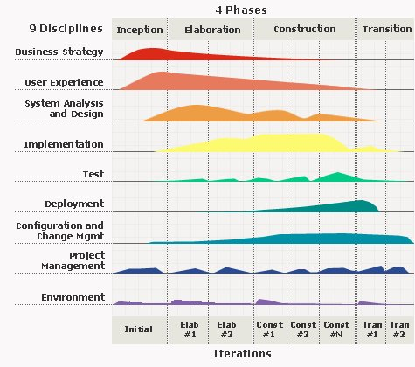

**Figure 2-1:** Rational Unified Process model overview

RUP is based on a set of building blocks, or content elements, describing what is to be produced, the necessary skills required and the step – by – step explanation describing how specific development goals are to be achieved. The main building blocks, or content elements, are the following.

**Workers (who)**:defines the behavior and responsibilities of an individual, or a group of individuals working together as a team.

**Artifacts (what)**: An artifact is a piece of information that is produced, modified, or used by a process. Artifacts are the tangible products of the project, the things the project produces or uses while working towards the final product.

**Activities (how)**:An activity of a specific worker is a unit of work that an individual in that role may be asked to perform.

**Workflows (when)**: is a sequence of activities that produces a result of observable value.

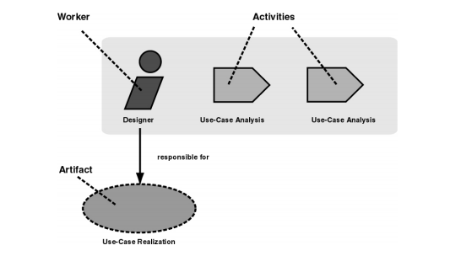

**Figure 2-2:** Workers, activities and artifacts

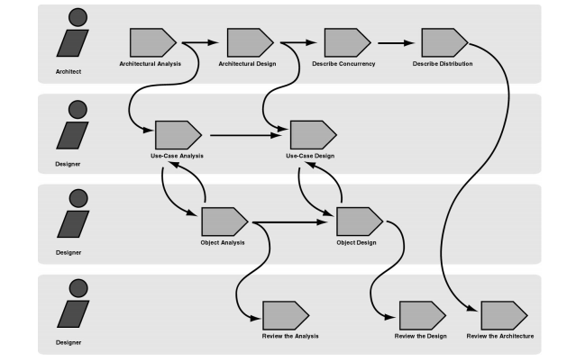

**Figure 2-3:** Example of workflow

RUP comes with six engineering disciplines and three supporting discipline

**- Six “engineering disciplines”:**

* + **Business modeling workflow**: In Business Modeling we document business processes using so called business use cases. This assures a common understanding among all stakeholders of what business process needs to be supported in the organization.
  + **Requirements workflow**: The goal of the Requirements workflow is to describe what the system should do and allows the developers and the customer to agree on that description.
  + **Analysis and design workflow**: The goal of the Analysis & Design workflow is to show how the system will be realized in the implementation phase.
  + **Implementation workflow**: The purpose of implementation is to define the organization of the code, to implement classes and objects in terms of components, to test the developed components as units, to integrate the results produced by individual implementers.
  + **Test workflow**: The purposes of testing are to verify the interaction between objects, to verify the proper integration of all components of the software, to verify that all requirements have been correctly implemented, to identify and ensure defects are addressed prior to the deployment of the software.
  + **Deployment workflow**: The purpose of the deployment workflow is to successfully produce product releases, and deliver the software to its end users. It covers a wide range of activities including.

**- Three supporting disciplines:**

* + **Configuration and change management workflow**: Software Project Management is the art of balancing competing objectives, managing risk, and overcoming constraints to deliver, successfully, a product in which meets the needs of both customers (the payers of bills) and the users.
  + **Project management workflow**: In this workflow we describe how to control the numerous artifacts produced by the many people who work on a common project.
  + **Environment workflow**: The purpose of the environment workflow is to provide the software development organization with the software development environment – both processes and tools – that are needed to support the development team.

### **Why RUP?**

The Rational Unified Process provides each team member with the guideline, templates and tool mentors for the entire team to take full advantage of among others the following best practices:

**- Develop iteratively**: It is not possible to sequentially first define the problem upfront, design the entire solution, build the software and then test the product at the end. Each iteration ends with a release. The RUP supports an iterative approach to development that addresses the highest risk items at every stage in the lifecycle, significantly reducing a project’s risk profile. This is very important for our team that is very inexperienced in controlling issues.

**- Manage requirements**: the RUP describes how to elicit, organize and document required functionality and constraints; track and document tradeoffs and decisions; and easily capture and communicate business requirement. The notations of use case and scenarios proscribed in the process has proven to be an excellent way to capture functional requirements and to ensure that these drive the design, implementation and testing of software, making it more likely that the final system fulfills the end user needs.

**- Use Component – based Architectures**: the process focuses on early development and baselining of a robust executable architecture, prior to committing resources for full – scale development. It describes how to design a resilient architecture that is flexible, accommodates change, is intuitively understandable and promotes more effective software reuse.

**- Visually Model Software**: this process allows you to hide the details and write code using “graphical building blocks.” Visual abstractions help you communicate different aspects of your software; see how the elements of the system fit together; make sure that the building blocks are consistent with your code; maintain consistency between a design and its implementation; and promote unambiguous communication.

**- Verify Software Quality**:The Rational Unified Process assists you in the planning, design, implementation, execution, and evaluation of these test types. Quality assessment is built into the process, in all activities, involving all participants, using objective measurements and criteria, and not treated as an afterthought or a separate activity performed by a separate group.

**- Control Changes to Software**: And it brings a team together to work as a single unit by describing how to automate integration and build management

### **Project Life Cycle**

The RUP is “use – case driven, architecture – centric, and incremental and iterative”. Each iteration is part of four overall phases: Inception, Elaboration, Construction, and Transition. Iterations occur in each phase. Each phase has one key “*objective*” and “*milestone*” at the end that denotes the objective being accomplished.

**- Inception Phase:**The primary objective is to scope the system adequately as a basis for validating initial costing and budgets.

* + Identify business functions of the system
  + Determining the scope, conditions and limitations of the project
  + List the main functions of the system
  + List one or more suitable architecture for the system
  + Identify project risks
  + Complete Report #1, and Report #2

**- Elaboration Phase:**

* + In this phase of the project team to understand the function of the system, which evaluate the system's architecture and provide a stable system architecture can implement all the requirements is scalable and suitable price..
  + Finally, the plan must provide (including estimates of cost and time) for the construction phase. The plan must ensure proper and accurate based on experience.
  + Complete Report #3 and Report #4

**- Construction Phase:**

* + This is the longest phase of a project life cycle.
  + In this phase, all functions of the system will be installed. The installation will be divided into small stages, each stage of the installation a few functions. The results of each phase will be the release of the module function can be executed.
  + Construction and improvement of products until the final product is ready to deliver to the user. During this phase, all the components and other features of the application is developed and integrated into the product.
  + This phase emphasizes the resource management and control operations to optimize cost, time and quality.
  + Complete software packages and Report #5, Report #6

**- Transition Phase:**

* + This is the final phase in the life cycle of a project.
  + Their products will be deployed to the client. The feedback received during the transfer process will be recorded and put on the new functional requirements or functionality enhancements in the next version of the product.
  + Phase transfer switch also includes the training system and the new system for the user.

## Roles and Responsibilities

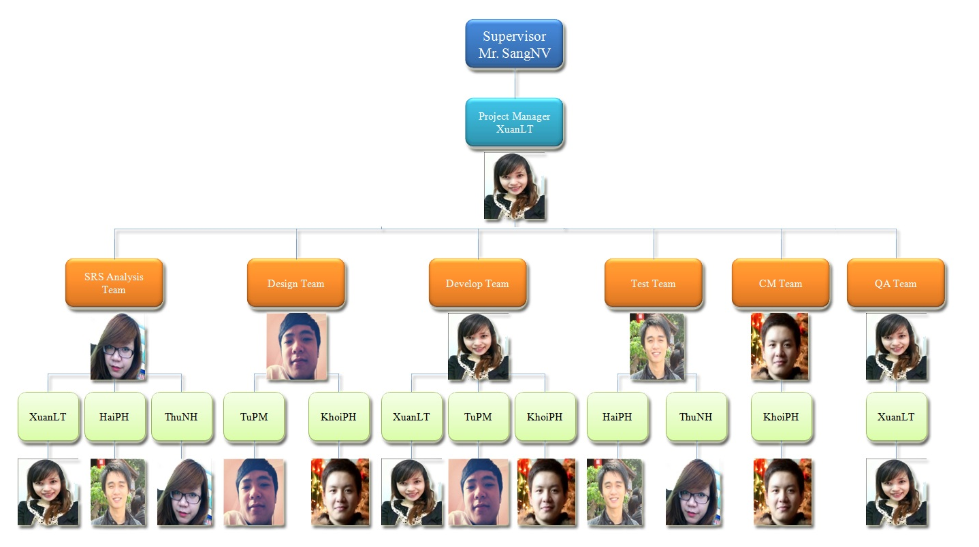

**Figure 2-4**: Project Organization

|  |  |  |
| --- | --- | --- |
| **Member** | **Roles and Responsibilities** | |
| **Roles** | **Responsibilities** |
| **XuanLT** | - Project Manager.  - Developer Leader.  - SRS Analysis. | - PM has responsibilities to develop the project plan and manage project stakeholders, project team, project risk, project schedule, project budget, project conflicts.  - Ensure that the Project Team completes the project.  - Secure acceptance and approval of deliverables from Project Sponsor and Stakeholder.  - Communication with other members and supervisor, including status reporting, making sure the project is delivered in budget, on schedule and within scope.  - Create WBS.  - Provide suitable technology solutions, tools for project development process.  - Conduct research and demo function that related to the project.  - Create coding guidelines, coding convention and standards.  - Co-operate with Developer to create software specification requirement (SRS), architectural design (SAD) and software detailed design (SDD).  - Review document, product, and reports.  - Unit test.  - Support other team members. |
|  | | |
| **HaiPH** | -SRS Analysis  - Tester Leader | - Create software specification requirement (SRS).  - Develop the test plan based on project plan and SRS, SDD documents.  - Delegate testing tasks to testers and manage the rate of progress.  - Create test data for all functions in both mobile and web application.  - Create test cases for the system, both in document and script.  - Write report  - Execute test to ensure all functions fulfil requirements.  - Support other team members. |
|  | | |
| **KhoiPH** | - Designer  - Developer  - CM Leader | - Design and develop mobile interface.  - Draw and complete architectural design on mobile.  - Develop all functions on mobile.  - Create and review SRS, SAD and SDD documents.  - Conduct research and demo function that related to the project.  - Conduct research how to install environment (include test and develop environment) and tools attach guidances.  - Support in every configuration – concerned problems.  - Managing configuration.  - Unit test and assure coding quality.  - Support other team members. |
|  | | |
| **TuPM** | - Designer Leader  - Developer | - Design and develop full web interface.  - Develop a plan to draw and control architectural design.  - Recommend the suitable and effective design.  - Create and review SRS, SAD and SDD documents  - Create Database such as create table, store procedure, transaction.  - Develop functions on web application.  - Unit test and assure coding quality.  - Support other team members. |
|  | | |
| **ThuNH** | -SRS Analysis Leader  - Tester | - Create software specification requirement (SRS).  - Understand business related to project topic.  - Present and explain business information to other members.  - Support the syntax and semantic of English language.  - Create test data for all functions in both mobile and web application.  - Create test cases for the system, both in document and script.  - Write report.  - Execute test to ensure all functions fulfill requirements and make test report.  - Support other team members. |

**Table 2-4** : Roles and Responsibilities

## Tools and Infrastructures

### **Development environment**

|  |  |
| --- | --- |
| **Title** | **Detail** |
| **Software and Framework** | **Software:**  - Microsoft® Office, Microsoft® Project (2007, 2010)  - Operating System: Microsoft® Windows 7  - Source Control: Tortoise SVN 1.7.9  - Adobe Photoshop CS5  - Eclipse Indigo  - MySQL 5.6.11.0 and Tomcat 6  - Browser: Chrome 25 , Firefox 20  **Framework:**  - Integrated Struts2, Spring3, Hibernate3  - Java language  - Android OS version 2.3 or higher  - .NET 4.0 ( setup MySQL ) |
| **Hardware** | Notebooks for developing/testing with the minimum configuration:  RAM:2GB Hard disk: 150GB Chipset: Core 2 Dual 2.0 GHz |
| A server computer with the minimum configuration:  RAM: 2GB  Hard disk: 150GB  Chipset: Core 2 Dual 2.0 GHz |
| Smartphone support Android OS 2.3 or higher with GPS and Wi-Fi powered for testing and deploying purposes.  Chipset: 1GHz  RAM: 1GB  Memory: 8 GB or higher |

**Table 2-5:** Tools and Techniques

### **Deployment environment**

Software Framework: Strut2, Spring3, Hibernate3, .NET 4.0, Android and Java language.

SMD (web) can runon some browsers : Chrome 25 , Firefox 20, .

SMD application ( mobile ) apply for Smartphone support Android OS version 2.3 or higher.

Server configuration: The server is a place to store data, source code and update all when have request, so it should be required the best equipment.

When equipped servers, it‘s necessary to pay attention to the following element:

- Configuration suggestions on web

* + Client Computer /Laptop: Core dual 2 GB RAM
  + CPU: Core dual 2 GB RAM
  + Operating Systems: Windows 7
  + Free Space: 2Gb

- Configuration suggestion on mobile:

* + Smartphone: 1 GB RAM
  + Memory: 16 GB
  + Chipset: 1.5 GHz
  + OS: Android 2.3 or higher

- Configuration suggestion on database server:

* + Client Computer /Laptop: Core dual 2 GB RAM
  + CPU: Core dual 2 GB RAM
  + Operating Systems: Windows 7
  + Free Space: 2Gb

# **Project Schedule**

## Task Sheet: Assignments and Timetable

Overall duration of project: 77 days (from 13th May 2013 to 27th August 2013)

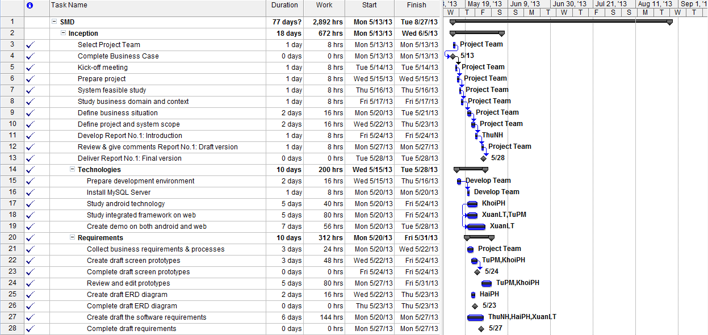

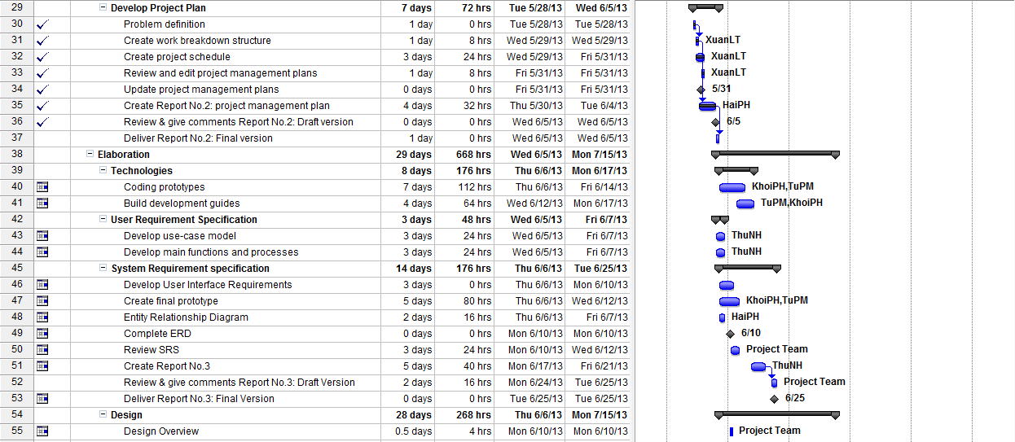

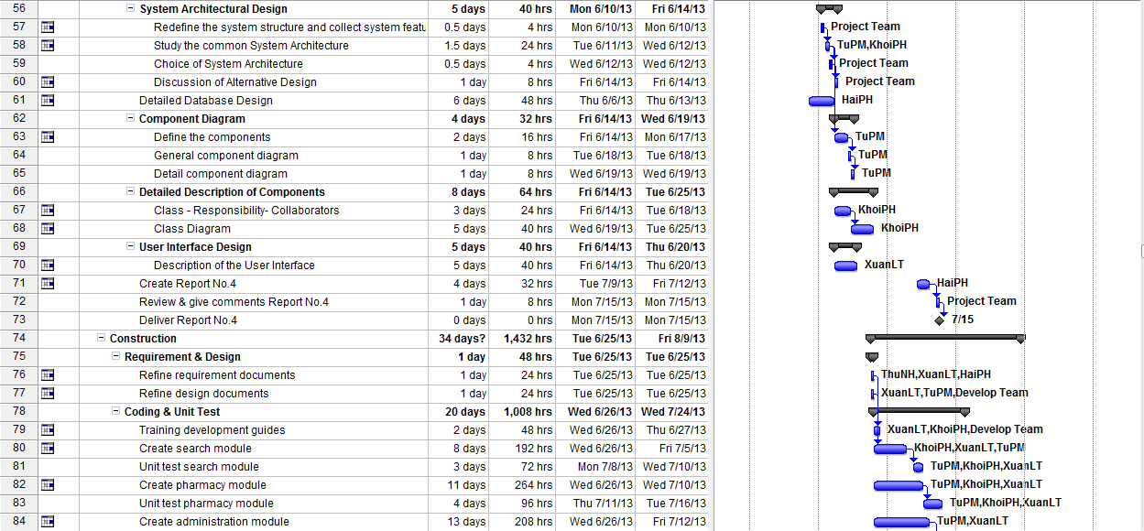

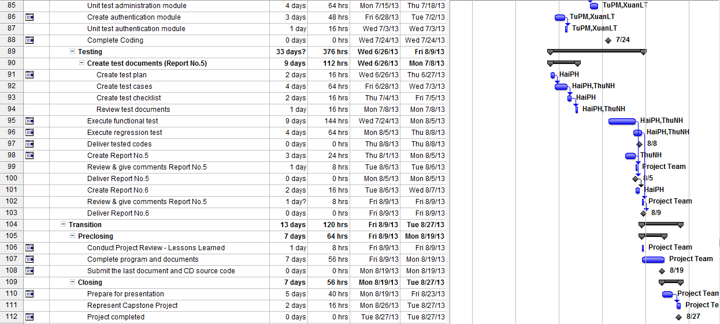

**Figure 2-5:** Work Breakdown Structure and Resource Assignment

## Meeting Schedule

Because of the project doing in the short time, we have to hold the meeting regularly, at least twice a week:

**- Meeting with team members:** In these meetings, each member will report their tasks in previous week to the others. The issues, knowledge and rules will be shared. Moreover, PM conduct the discussion of the plan in next week.

**- Meeting with supervisor:** all the activities, the issues will be discussed and reported with supervisor in last week. With the senior experience, supervisor will instruct the direction for project team to deal with the problems.

Below is a sample meeting minute template used for the project:

|  |  |  |  |
| --- | --- | --- | --- |
| **Subject** | Capstone Project Meeting | **Date** | Every Tuesday |
| **Facilitator** | FPT University | **Time** | 16:00 – 18:00 PM |
| **Location** | Detech Building, Cau Giay Str. | **Scribe** | ThuNH |
| **Attendees** | SangNV(Supervisor), XuanLT( PM), HaiPH, KhoiPH, TuPM, ThuNH | | |
| **Absent** |  | | |

| **Key Points Discussed** | | |
| --- | --- | --- |
| No | Topic | Highlights |
| 1. | Team member problems | * All the activities, the issues will be discussed and reported with supervisor in last week. * Discuss all issues & problems on the job last week * Discuss the working plan next week |
| 2. | Project introduction | * Instruct the direction for project team to deal with the problems * Support & comments the working​​ plans next week |

|  |  |  |  |
| --- | --- | --- | --- |
| **Action Plan** | | | |
| **No** | **Action Items** | **Owner** | **Target Date** |
| 1 | **Report #1**- INTRODUCTION | ThuNH | 28-May-2013 |
| 2 | **Report #2**: SOFTWARE PROJECT  MANAGEMENT DOCUMENTS | HaiPH + XuanLT | 6-June-2013 |
| 3 | **Report #3**:SOFTWARE REQUIREMENTS SPECIFICATION | HaiPH + ThuNH | 25-June-2013 |
| 4 | **Report #4**: SOFTWARE DESIGN  DESCRIPTION | XuanLT + TuPM + KhoiPH | 17-July-2013 |
| 5 | **Report #5**: SOFTWARE TEST  DOCUMENTATIONS | ThuNH | 5-August-2013 |
| 6 | **Report #6**: SOFTWARE USER‘S  MANUALS | HaiPH | 9-August-2013 |

**Table 2-6:** Meeting Schedule

# **Effort Estimation**

|  |  |  |  |  |
| --- | --- | --- | --- | --- |
| **Task Name** | **Worst Case** | **Best Case** | **Most likely Case** | **Expected Case** |
| **Inception** | **733** | **612** | **672** | **672** |
| Initiation | 104 | 70 | 88 | 88 |
| Technologies | 213 | 180 | 200 | 199 |
| Requirements | 332 | 294 | 312 | 312 |
| Develop Project Plan | 84 | 68 | 72 | 73 |
| **Elaboration** | **730** | **586** | **668** | **665** |
| Technology | 190 | 150 | 176 | 174 |
| User Requirement Specification | 60 | 44 | 48 | 50 |
| System Requirement Specification | 190 | 152 | 176 | 174 |
| Design | 290 | 240 | 268 | 267 |
| **Construction** | **1,536** | **1,344** | **1,432** | **1,435** |
| Requirements & Design | 54 | 40 | 48 | 48 |
| Coding | 1072 | 960 | 1,008 | 1011 |
| Testing | 410 | 344 | 376 | 376 |
| **Transition** | **144** | **106** | **120** | **123** |
| Pre-closing | 74 | 56 | 64 | 65 |
| Closing | 70 | 50 | 56 | 58 |
| **Total** | **3,143** | **2,648** | **2,892** | **2,895** |

**Table 2-7:** Effort Estimation

# **Risk Management**

|  |  |  |  |  |
| --- | --- | --- | --- | --- |
| **ID** | **Risk Content** | **Propability** | **Effect** | **Solution** |
| **#** | **People Risks** |  |  |  |
| 1 | Team member is not hard working, do not follow deadline. | HIGH | SERIOUS | - Find out reason why?  - Depending on circumstances, may set penalty rule. |
| 2 | Team members are sick, they can not complete task under deadline | HIGH | SERIOUS | - Increase project team’s working effort in “peace period”. - Allow all team members clear about what others do, so that they can cover the tasks when necessary. |
| 3 | Conflictions between team members. | HIGH | SERIOUS | - Setup an open-talk environment in project team. - “*Do not criticize*” is set as a rule. - Organize team-building more often.  - In some cases, manager must use her power to make decisions. |
| 4 | Poor experience makes plan late.Study new technologies have many difficult to apply for project | HIGH | SERIOUS | - List tasks and check continuously. Evaluate quality and progress weekly.  - Send email to other member to ask for help. |
| 5 | Bad communication breakdown can make changing time, work and delay plan | HIGH | SERIOUS | - We need using words more clearly, talk with each other more, note and send email to confirm information. |
| **#** | **Technical Risk** |  |  |  |
| 6 | We have not much knowledge in the framework and technique of both mobile and web. Therefore, we have to study all of these things from the beginning. This work may takes a lot of times or team may not resolve some technical problems. | HIGH | SERIOUS | - Divided into 2 technology research groups: one for mobile and one for web.  - Exchange information and problem.  - Send technical issues to supervisor who has experience to get support. |
| 7 | Eclipse is very error-prone. | HIGH | SERIOUS | - Errors brought up the big technology forum.  - Record the occurred error and how to fix it. |
| **#** | **Structure/ Process Risk** |  |  |  |
| 8 | Underestimate project scope, tasks’ difficulty level and risks’ effectiveness. | HIGH | SERIOUS | - Estimate project scope with supervisor and experience persons.  - Assign task weight value to make task evaluation easier. Discuss in group about tasks’ difficulty level.  - Involve all team members in risk management process and reference to instructor’s opinions. |
| # | **Requirement Risk** |  |  |  |
| 9 | Notunderstandingthe system'sprocess, so we can have mistakesin describingtheessential functions | HIGH | SERIOUS | - Receive advice from experts  - Develop prototypes and review prototypes with experts and supervisor |
| # | **Testing Risk** |  |  |  |
| 10 | Location access through GPS satellite in mobile is depended so much on the infrastructure of the network providers. therefore, development & test may get stuck when service is not stable then the progress may be slower than plan. | HIGH | SERIOUS | Use two network providers for testing environment and development environments |
| 11 | Android device problem, because no member in our team have an android device. ( launch application on emulator is very slow, some function can not run on emulator as draw line between two points on map ) | HIGH | SERIOUS | - Borrow someone else’s device.  - Be careful to avoid damage because they are quite expensive. |
| # | **Management Risk** |  |  |  |
| 12 | Poor experience of management so that team makes plan unrealistically | HIGH | SERIOUS | -Team leader will tightly co-operate with team members when planning.  - Project team get advice from supervisor about the planning and the plan need to be reviewed by supervisor. |

**Table 2-8:** Risk Management